**Bocada Data Domain**

**Plugin Configuration Guide**

# Contents

Contents 1

1 Data Domain Configuration Checklist 2

Note on Initial Collections 2

2 Supported Collection Types 2

3 Data Sources 2

4 Requirements 3

4.1 Port Configuration 3

4.2 PuTTY 3

4.3 Bocada Data Domain Service 4

5 Bocada Setup 4

5.1 Backup & Storage Properties 4

6 Bocada Data Domain Reports 5

6.1 Data Domain replication job reports 5

6.2 Data Domain Storage is in dedicated reports 5

6.3 Data Domain Capacity Report 6

6.4 Data Domain Mtree Trends Report 7

6.5 Data Domain Mtree Trends Tabular Report 8

6.6 Data Domain File Age and Size Distribution Report 9

7 Troubleshooting 10

7.1 General Troubleshooting 10

7.2 Troubleshooting Data Collection: Cachekey.bat needs to be run 10

7.3 Troubleshooting Time-out Settings 11

7.4 Troubleshooting Slow Storage Collection Updates 12

8 Technical Support 13

# Data Domain Configuration Checklist

While detailed steps are included below, this is an overview of the steps to configure Data Domain collections on your Bocada Data Collection Server (DCS):

* Install PuTTY on your Bocada Server.
* Ensure that the *Bocada Data Domain Service* is run as a dedicated Windows Domain User account.
  + Note that the services domain user account must be added to the DCS as an Administrator.
  + Note that you must be able to log in to your DCS using that account while configuring Bocada.
* Verify required TCP ports have been opened.
* Obtain a read-only user for Data Domain.
* Run Cachekey.bat as needed, and restart Bocada Data Domain service

Note on Initial Collections

All or most Data Domain job activity is seen under the backup server backing up to that Data Domain, and the Data Domain itself may not perform backups of its own. Initial collections from your Data Domain may not appear to be collecting backup jobs. If the Data Domain does have backup jobs, then those will be replication jobs. Similarly, Storage collections will not be immediately reflected in the *Data Domain Capacity* line chart until at least two days’ Storage collections in order to render a line. Storage collections may be verified, however, by running a *Storage Servers* report filtered on Data Domain as the product.

# Supported Collection Types

The Bocada Data Domain plugin supports the following collection types:

|  |  |  |
| --- | --- | --- |
| **Collection Type** | **Supported** | **Description** |
| Backup | ✓ | Collects transactional details about replication jobs. Example metrics include, start times, durations, bytes, files, errors etc. |
| Storage | ✓ | Collects point-in-time inventory information. Example metrics include, total recoverable gigabytes (storage), media volume count, media volume status, etc. |
| Policy |  | Collects and stores information on policy attributes, schedules, storage units, storage groups, storage lifecycle policies and clients. |

# Data Sources

The Data Domain Plugin mines backup data by a Bocada service that connects to the Data Domain appliance and runs native DD commands, such as “system show version”, “df”, “filesys show space”, “filesys show compression”, etc.

# Requirements

This section lists requirements that must be met prior to collecting data with the Bocada plugin for Data Domain.

You can use read-only credentials (username and password) for your Data Domain.

The windows service named *Bocada Data Domain Service* must be run as a Windows domain user account (not local system); Bocada recommends that this be a dedicated windows domain user account with a non-expiring password.

The *Bocada Data Domain Service* will connect to Data Domain to run the commands. Other Bocada services can still run with different account credentials, such as Local System, although it is recommended that all Bocada services run as windows users.

## Port Configuration

The following ports are required to be open for the plugin to communicate with Data Domain for the collection of data:

|  |  |  |  |
| --- | --- | --- | --- |
| **TCP/UDP** | **Default Port** | **Direction** | **Notes** |
| TCP | 22/TCP | Incoming | SSH Default Port |

## PuTTY

Data Domain connectivity relies on PuTTY, an open-source SSH and Telnet client. PuTTY will need to be installed onto each Bocada Data Collection Server (DCS) that will be connecting to a Data Domain.

***Installation***

1. You can download PuTTY, and learn more about it here: <https://www.putty.org/>
2. Download the 32-bit or 64-bit MSI (installer package, 64-bit recommended) from the *Latest Release* page.
3. Run the downloaded MSI or Save As to a convenient staging location and run it from there. This will launch the PuTTY Setup Wizard.
4. The only configuration options during PuTTY installation are the install directory location and simple Product Features.
5. **Note**: Upon trying Backup Update collection, the Bocada DCS will detect if the necessary registry key is cached. If the cached key is not found, then
   1. Start a command line tool in windows with the same user that is running the Bocada Data Domain service. (Alternative: or you can log in to the Bocada Data Collection Server as the same user that is running the Bocada Data Domain Service.)
   2. Run the cachekey.bat file for each Data Domain server. The cachekey.bat files are created when you run Test Connection or try to collect data. Bocada will show you the path to the cachekey.bat file.
   3. Enter the password for the Data Domain user when prompted.
   4. (Alternative to steps a, b, and c above: you can use the PuTTY UI (User Interface) to manually connect to each Data Domain server separately. This opens an SSH tunnel from the data collector to the server.
6. **Restart** the Bocada Data Domain service after running cachkey.bat or the PuTTY UI for all of your data domains.
7. Test by running a manual data collection.

## Bocada Data Domain Service

The Bocada Data Domain Service must be run under a Windows Domain user that has been added to the DCS Server as an administrator.

1. Open Control Panel --> Administrative Tools --> Services.
2. Right click the *Bocada Data Domain Service* --> *Properties* --> *Log On* (tab).

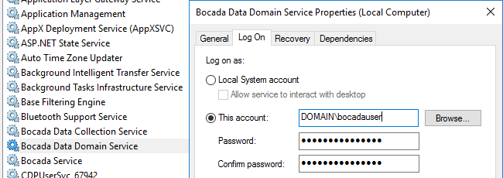

1. Verify that the service account is an administrator on the DCS.
2. Apply and restart the service.

# Bocada Setup

Adding a Data Domain to Bocada is the same as setup of any backup server.

## Backup & Storage Properties

Backup Server Properties determine how the plugin will interface with the Data Domain and are managed through the Backup Servers view.

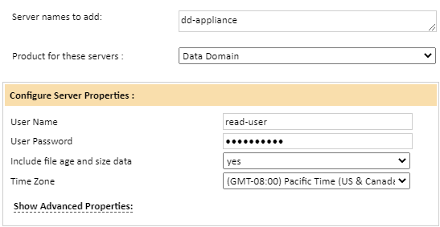

|  |  |
| --- | --- |
| Property | Description |
| User Name | Enter a Data Domain user with at least Read permissions. (Standard credentials will work; Administrator access is not required). |
| User Password | Enter the password for the Data Domain user above. |
| Include file age and size data | Set this to *yes* in order to see Data Domain file age and size data in reports. Note that this setting can impact data collection performance. If this prevents timely collection of data, set to *no*. |
| Time Zone | Enter the Time Zone used by the Data Domain. |

Table 1: Home Module

# Bocada Data Domain Reports

Byte counts: The Data Domain reports all show bytes in binary GB aka GiB. This matches the way data is displayed in the DD UI and DD command line output.

Replication Jobs only: Most activity to a Data Domain will appear under the backup product which is performing the backups to the Data Domain. You will only see Replication jobs done from one DD to another DD under each DD server in the reports.

Media Type: In addition to the Data Domain Plugin, some Bocada Plugins identify whether backup jobs are being backed up to Data Domain as Media Type. As of 2018-04-01, the implemented Backup Products include: TSM, Avamar, NetBackup, Networker, Veeam, Backup Exec, CommVault, and Data Protector.

Unknown clients: For many backup products, it is not uncommon to see the Client name as “unknown” in Storage data, because only a path is seen by the plugin. Every Data Domain server in Bocada is expected to display at least one “unknown” client with Media Group equal to the path set for backup. This “unknown” client will not display any associated jobs.

## Data Domain replication job reports

If you are replicating data between data domains, then you will see those replication jobs reported in the usual Bocada backup job reports. Those reports, such as Job Trends and Job Activity reports, are described in the Bocada Reporting Guide. You will see jobs reported for both the source Data Domain and the destination data domain. Job types include:

* File Replication Source
* File Replication Destination
* Mtree Replication Source
* Mtree Replication Destination

The byte count for replications jobs includes the file or Mtree data plus the meta data that is transferred.

## Data Domain Storage is in dedicated reports

Storage data collection in Bocada is based on a snapshot of the DD when the data was collected. For detailed comparisons of the values in DD with Bocada, you may wish to do a fresh data collection. There are four dedicated Data Domain storage reports in Bocada:

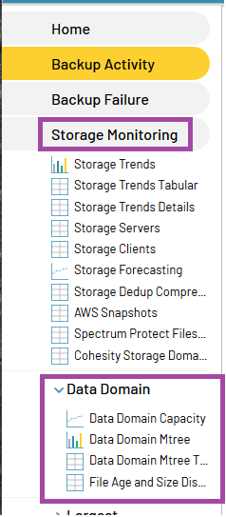

## Data Domain Capacity Report

The Data Domain Capacity report shows bytes in binary GB (1024 based) aka GiB.

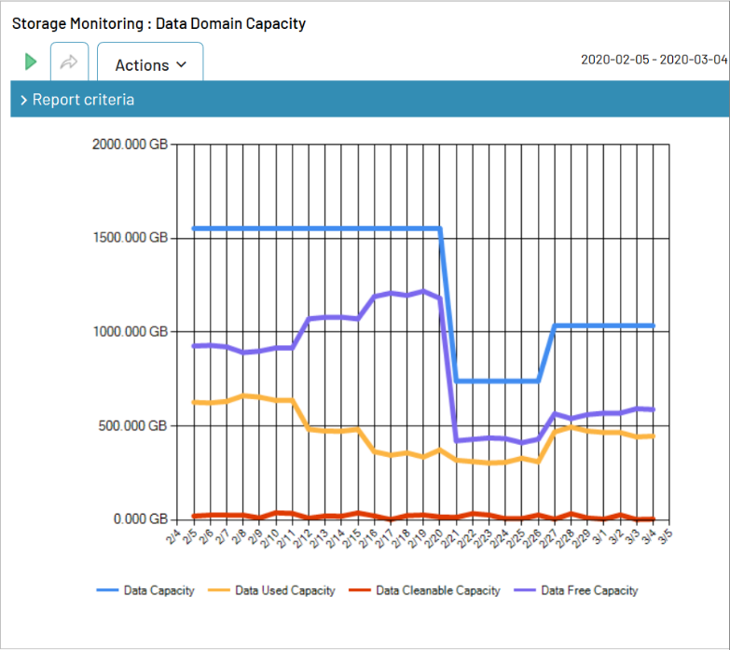

## Data Domain Mtree Trends Report

The Data Domain Mtree Trends report shows Mtree data bytes in binary GB (1024 based) aka GiB.

Based on what is shown in the DD command “filesys show compression /data/col1/<Mtree_name>” here is the mapping of data in this report

* **Pre-Comp bytes** in the report are the **“Logical Bytes”**
* **Post-Comp bytes** in the report are the **“Locally Compressed + Meta-data”**
* **Compression ratio** in Bocada is shown as **Pre-Comp/Post-Comp**

Note that DD shows compression ratio as Original Bytes/Post-Comp bytes, which is different from what Bocada shows.

## Data Domain Mtree Trends Tabular Report

The Data Domain Mtree Trends Tabular report shows bytes in binary GB (1024 based) aka GiB.

Based on what is shown in the DD command “filesys show compression /data/col1/<Mtree_name>” here is the mapping of data in this report

* Pre-Comp bytes in the report are the “Logical Bytes”
* Post-Comp bytes in the report are the “Locally Compressed + Meta-data”
* Compression ratio in Bocada is shown as Pre-Comp/Post-Comp
* Note that DD shows compression ratio as Original Bytes/Post-Comp bytes, which is different from what Bocada shows.

## Data Domain File Age and Size Distribution Report

The Data Domain File Age and Size Distribution report shows bytes in binary GB (1024 based) aka GiB.

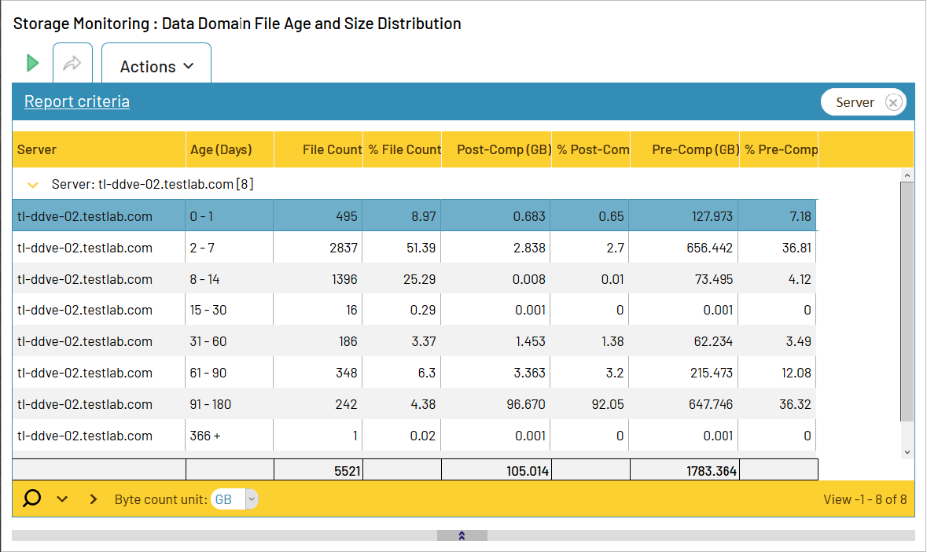

# Troubleshooting

## General Troubleshooting Info

Data Domain additional logging can be found on each DCS in the file BocadaDataDomain.log typically found in the following location:

<Bocada_Install_Folder>\Bocada\DataCollection\log\BocadaDataDomain.log

e.g.

C:\Program Files (x86)\Bocada\DataCollection\log\BocadaDataDomain.log

This log file is automatically and continuously added to, with a default maximum size of 10MB. The maximum file size is controlled by the configuration file:

...\Bocada\DataCollection\bin\BocadaDataDomainLogger.config

The maximum file size can be changed in this line of the file.

<maximumFileSize value="10MB" />

## Troubleshooting Data Collection: Cachekey.bat needs to be run

If the Test Connection or data collection fails, and tells you to run Cachekey.bat or some of the following errors:

* “Error 545: ApplicationException: Unable to connect to Data Domain Server for unknown reasons. Please run CacheKey.bat: c:\program files(x86)\bocada\datacollection\snashot\datadomain\testconn\<servername>”
* “Failed: ApplicationException: The Server host key is not cached in the registry. Please run CacheKey.bat: c:\program files(x86)\bocada\datacollection\snashot\datadomain\testconn\<servername>”

Then please follow the steps described below. This behavior is expected if PuTTY version 0.77 or earlier is installed on the Bocada DCS, but has been seen for other cases.

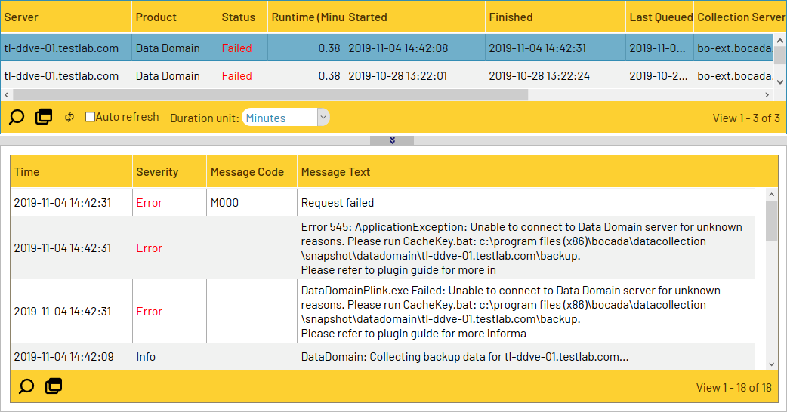

The Bocada DCS will detect if the necessary registry key is cached. If the is not caches then:

1. Start a command line tool in windows *with the same user* that is running the Bocada Data Domain service. Note: if you run the command line as administrator then
2. Run the cachekey.bat file for each Data Domain server.
   * The file is created when you do a try to collect data.
   * Start a windows command prompt with Run as Administrator.
   * Type cd to folder <Bocada_Install_Folder>\Bocada\datacollection\snapshot\datadomain\ <server name>\backup
   * Run the cachekey.bat from the command window.
3. When prompted “*Store key in cache ? (y/n)*” enter y.
4. When prompted “*Password*” enter the password for the *Data Domain user*.
5. **Restart** the Data Domain service when finished!
6. Test by running a manual data collection.

If the Cachekey.bat does not run for you then you can alternatively Connect to each Data Domain server with the PuTTY User Interface tool. You must start the PuTTY UI with the same account that is running the Bocada Data Domain service. If you have trouble starting the CMD tool or the PuTTY UI as another user then you will need to log in to the Bocada Data Collection Server as the same user that is running the Bocada Data Domain Service, and perform all steps as that user. You must restart the Data Domain service after you run the PuTTY UI.

## Troubleshooting Time-out Issues

Several different underlying problems may cause a timeout error message.

### Timeout due to Connectivity

If the Bocada Data Collection server cannot reach the Data Domain device on port 22 then you will see a timeout. You can independently test the connectivity using telnet client as follows:

1. Open Windows command prompt and type the following command, putting in your DD name”
2. telnet <datadomainname> 22
3. If the firewall and port are open, then you will see a blank screen come up as 22 accepts the connection.
4. If the system cannot be reached you may see a message such as for this telnet command and response:

C:\> telnet mydd 22

Connecting To mydd...Could not open connection to the host, on port 22: Connect failed

### Timeout Setting Needs to be Extended

The default time-outs for Data Domain collections are set when installing or upgrading Bocada to one (1) hour. If your environment requires a different time-out setting, these may be changed in the PuTTY .conf files:

1. Stop the Bocada Data Domain Service
2. Edit the following .conf files:
   1. BocadaDataDomain.exe.config

<binding openTimeout="01:00:00" closeTimeout ="01:00:00" receiveTimeout="01:00:00" sendTimeout="01:00:00">

* 1. DataDomainPlink.exe.config

<binding name="NetTcpBinding_Service" openTimeout="01:00:00" closeTimeout ="01:00:00" receiveTimeout="01:00:00" sendTimeout="01:00:00"/>

3. Restart Service

4. Run updates

## Troubleshooting Slow Storage Collection Updates

Try setting the Include file system data server property to “*no”* if your storage data collections are slow. This will skip some data collections that take a long time on some large Data Domain servers.

# Technical Support

For technical support or a copy of our standard support agreement, please contact us.

**E-mail:** [support@bocada.com](mailto:support@bocada.com)

**Support Portal:** <http://www.bocada.com/product-support/>

**Phone:** +1-425-898-2400